STATIC ROUTING
STEP 1
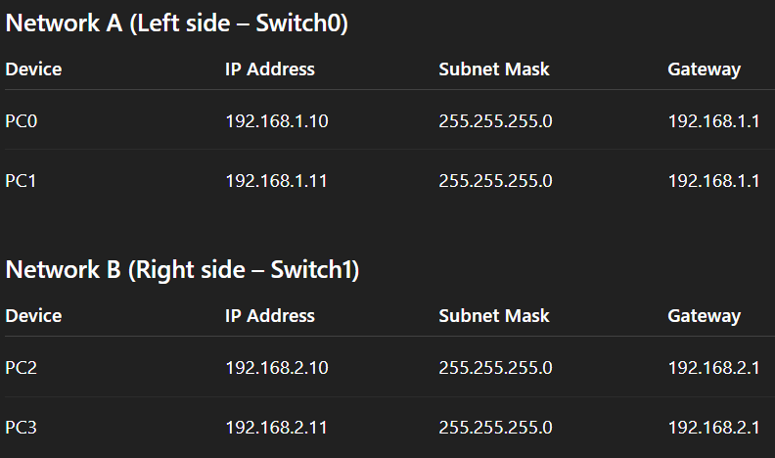
STEP 2

Router#enable
Router#conf t
Router(config)#interface FastEthernet0/0
Router(config-if)#ip address 192.168.1.1 255.255.255.0
Router(config-if)#no shut
Router(config-if)#exit
Router(config)#interface FastEthernet1/0
Router(config-if)#ip address 192.168.2.1 255.255.255.0
Router(config-if)#no shut
Router(config-if)#exit
Router(config)#end
Router#write
Building configuration...
[OK]
Router#OK
DYNAMIC ROUTING

